PhET Atom Simulator
Name: _____________________ Class: ____ Date: ______
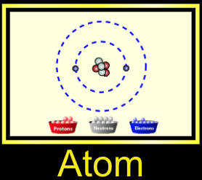
Part 1: Build an Atom
Click on the + sign for each of the boxes (element name, net charge and mass number) to view changes as you change the number of particles in the atom.

Directions: Create a Helium (He) atom (2 protons, 2 neutrons, 2 electrons). Follow the directions, observe what happens and complete the table below. (You need to RESET back to your original Helium (He) atom (2 proton, 2 neutrons, 2 electrons) after you make each change!)

 | Add a Neutron  (to original atom) | Add an Electron  (to original atom) | Add a Proton  (to original atom)
Observe and record ALL changes to the original Helium (He) atom when each subatomic particle is added! | How does it change the:  Overall charge: _________  Mass: _________________  Atomic Number: ________  Type of Atom: __________ | How does it change the:  Overall charge: _________  Mass: _________________  Atomic Number: ________  Type of Atom: __________ | How does it change the:  Overall charge: _________  Mass: _________________  Atomic Number: ________  Type of Atom: __________

Using your periodic tables, choose three elements (up to neon) and build their atoms using the simulator. Each atom must be STABLE and NEUTRAL. Fill in the information about them after you build each atom.
Element #2: ___________________
# of protons: _______
# of neutrons: _______
# of electrons: _______
Sketch:

Atomic #: _______
Atomic mass: _______
Element #1: ________________
# of protons: _______
# of neutrons: _______
# of electrons: _______
Sketch:

Atomic #: _______
Atomic mass: __________
Element #3: ________________
# of protons: _______
# of neutrons: _______
# of electrons: _______
Sketch:

Atomic #: _______
Atomic mass: ________

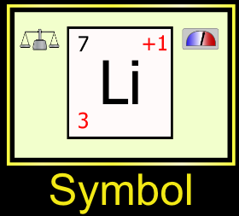
Part 2: Atoms and ions and isotopes, oh my!

Play with the simulation to discover:
- Which particle affects the charge of an atom or ion. ___________________
- Which particle changes the type of element your atom is. _______________
- Which particle makes the atom an unstable isotope (make sure to check the box at the bottom that says stable/unstable). ____________________

Atomic Number, Atomic Mass and Charge
Play with the simulation to identify what each number signifies. Label the diagram below.
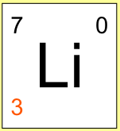
_______________________ ______ ___________

______________________

Design a stable Sodium atom. Design a stable Chlorine atom.

Draw it in the box below after you make it on the Draw it in the box below after you make it on the Chromebook. Chromebook.

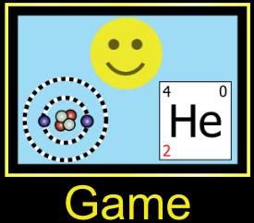

Part 3: Part 3: Click Game at the bottom of the simulator window. Play the four games- can you get all five stars each time?!

