Food Web Project
Goal: Create a food web based on a chosen ecosystem, with at least 3 food chains that interlock.
Materials: Chromebook, Google Slides, web sites, science journal

Requirements:
1-Must include at least 3 food chains that interlock to create a food web.

2-Must include at least 1 labeled decomposer.

3-Label your consumers (primary, secondary, tertiary), producers, decomposers.

4-Use arrows to show the direction of energy from one item to the next. Some items may have more than one arrow coming to it or leaving from it.

5-Also at the top of the food web label which ecosystem your food web represents.

6-You will be use Google Slides to create your food web. Follow the rubric on the last page to see how your project will be scored.

7-Turn in your project on your science Google Classroom.

8-Upload your Google Slide project to your portfolio.

9-Complete the questions on the back of this paper and turn them in.

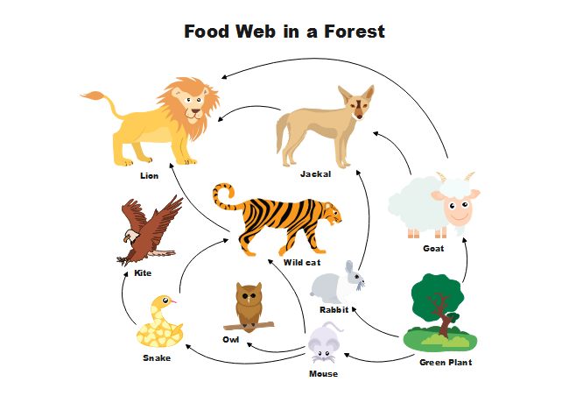
Rubric:
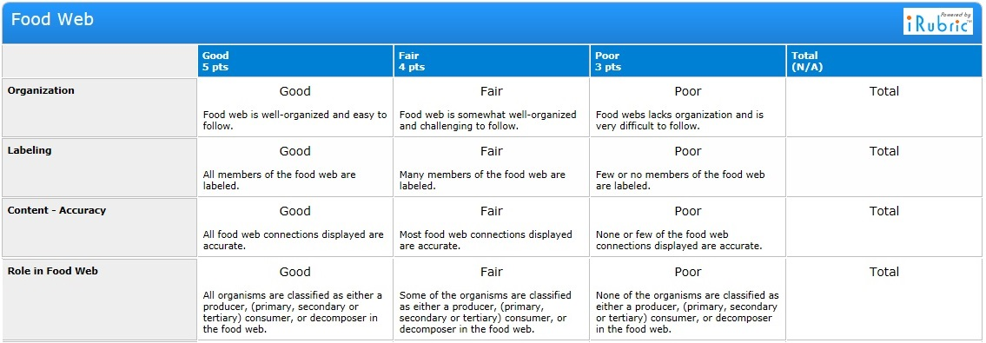

Questions:

1-What is a producer?

2-What is a consumer?

3-What is a decomposer?

4-What happens to the energy as you move up the food chain?

5-What would happen if one of your producers died out? How would it affect the other organisms in your ecosystem?

6-What would happen if one of your consumers died out in your ecosystem? How would that affect the other organisms in your ecosystem?

