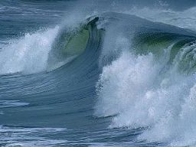
Ocean Waves and Ocean Currents
The water in the ocean is constantly moving. On the surface we see water moving in the form of waves. Below the surface the water moves in great currents.
What causes ocean waves?
One of the things many people love about the ocean is the waves. People love to play in the waves, surf the waves, and the sound of the waves crashing on the beach. Ocean waves are caused by wind moving across the surface of the water. The friction between the air molecules and the water molecules causes energy to be transferred from the wind to the water. This causes waves to form.
Ocean Currents
Ocean waters move from one region to another along established currents. A majority of the currents are circular in nature, operating between continents. They are important to the Earth's climate, and subsequently to the existence of hundreds, if not thousands of species of animal and plant life.
There are a number of ocean currents found around the Earth. A current is like a vast river within the ocean, flowing from one place to another. These currents are caused by the wind, differences in temperature, and by differences in salinity. Some currents are surface currents while other currents are much deeper flowing hundreds of feet below the surface of the water.
What causes ocean currents?
There are two types of ocean currents: surface currents and deep water currents. Surface currents are caused by the wind. As the wind changes, the current may change as well. The surface current consists mostly of the top 1,300 feet of water. Surface currents are also influenced by the rotation of the Earth called the Coriolis Effect. This causes currents to flow clockwise in the northern hemisphere and counter clockwise in the southern hemisphere.
Where the current originates can determine whether it is a warm water current or a cool water current. If it originates near the equator it will be a warm water current. If it originates near one of the poles it will be a cool water surface current. Some of the surface currents that affect the United States are the Gulf Stream current off the east coast of Florida and the California current off the coast of California.
Deep water ocean currents (Density currents) are different from surface water in two distinct ways. Deep water is much colder than surface waters, and deep water has a higher salt content. When salty water from a warm region is transported to a region that is cold, it tends to sink. This difference in density causes deep water currents. There are two major deep water currents in the world. The first is the North Atlantic deep water that originates near Iceland. The second major deep water current in the Antarctic circumpolar current that circles the South Pole.

World Wide Surface Currents
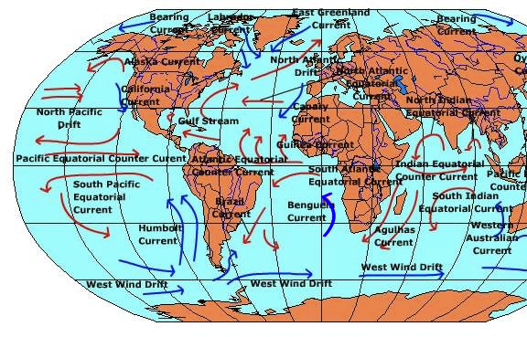

Do currents impact the climate?
Ocean currents can have a significant impact on climate. In some areas warm water is moved from the equator to a colder region causing the region to be warmer.
One example of this is the Gulfstream current. It pulls warm water from the equator to the coast of Western Europe. As a result, areas such as the United Kingdom are typically much warmer than areas at the same northern latitude in North America.
Interesting Facts about Ocean Waves and Currents
- The tallest wave recorded in the open ocean was 95 feet during a storm near Scotland.
- Surface currents are important to ships as they can make it easy or difficult to travel depending on the direction of the current.
- Some marine animals take advantage of currents to migrate thousands of miles to and from breeding grounds.
- Ben Franklin published a map of the Gulf Stream in 1769.
1-Define the following terms in your own words:
Surface current: ____________________________________________________________________________________________________________________________________________________________________________________
Density current: ____________________________________________________________________________________________________________________________________________________________________________________

2-Name the 2 surface currents near the United States and where they are located.
a. ________________________________________________________________________________________
b. ________________________________________________________________________________________

3-Name the 2 major deep water currents in the world and where they are located.
a.________________________________________________________________________________________
b.________________________________________________________________________________________
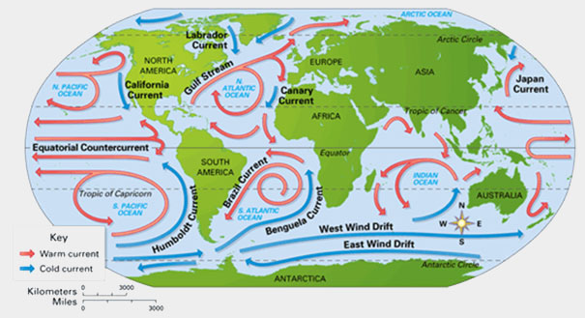
4- Using the map above infer whether the Humboldt Current is a warm or cool surface current.
____________________________________________________________________________________________________________________________________________________________________________________

One way the ocean affects the climate in places like Europe is by carrying heat to the north in the Atlantic Ocean. Way up north, cold water in the North Atlantic ocean sinks very deep and spreads out all around the world. The sinking water is replaced by warm water near the surface that moves to the north. Scientists call this the Great Ocean Conveyor Belt. The heat carried north helps keep the Atlantic ocean warmer in the winter time, which warms the nearby countries as well.
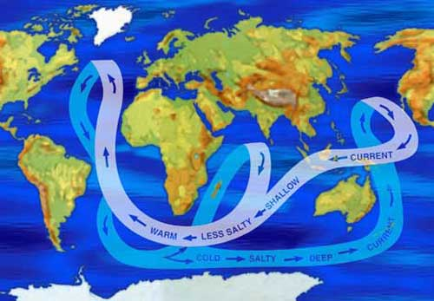
The Great Ocean Conveyor Belt carries warmer, less salty water from the equator to the poles, and colder, saltier water from the poles back toward the equator. Colder water and very salty water are heavier than warmer water and less salty water.
The water in the North Atlantic sinks because it's cold, but also because it's salty. Being both cold AND salty makes it really heavy, so it can sink very far. But if too much ice melts in the North Atlantic, the water could become less salty. If that happens, what about the Ocean Conveyor Belt? Would it stop warming the North Atlantic? Could Europe get really cold? Scientists say it seems unlikely, but NASA satellites are keeping a close eye on the melting ice and the ocean currents to try to understand this complicated system better.

